ព្រះរាជាណាចក្រកម្ពុជា

ជាតិ​ សាសនា ព្រះមហាក្សត្រ

Institute of technology of Cambodia

Department of Information and communication Engineering



The lesson taking about queue and stack in c++

TP17: Queue and Stack

TP: Algorithm and Programming ll

Lecturer: BOU CHANNA

Student: VEN THON

ID: e20191250

Group: I3-GIC-C

Contents

Poblem1: 3

Problem2: 5

Problem3: 6

Problem4: 7

Problem5: 8

# Poblem1:

Create an implementation of queue and stack as linked list. Put the implementation of as a header file (MyStack-Yourname.h) and the implement of queue as another header file (MyQueue-Yourname.h). you can reuse the Single linked list implementation then rename function and variable needed by to the terms(push, pop, top, rear, front, dequeue) used by Stack and Queue.

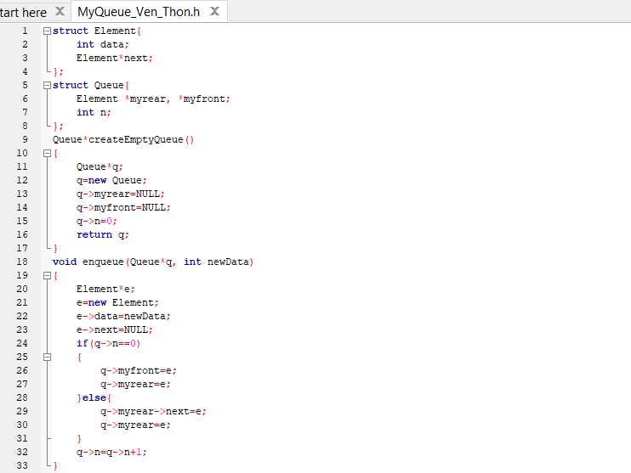

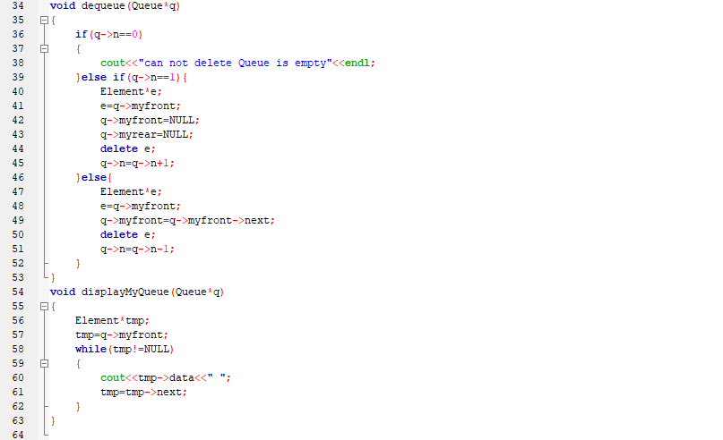

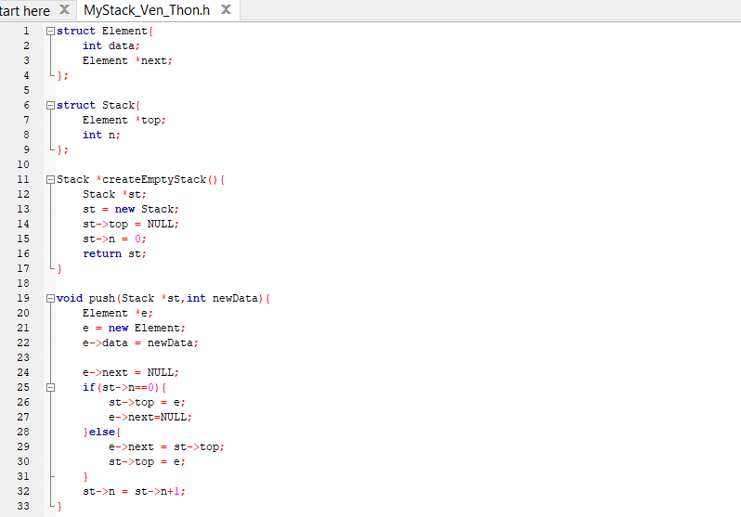

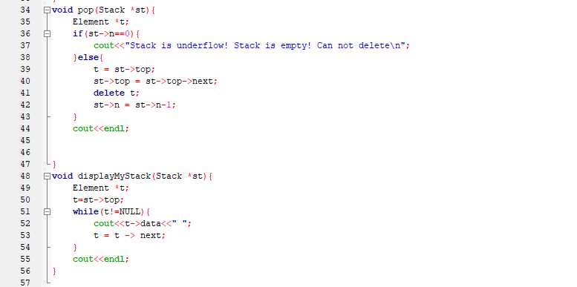

# Problem2:

Process each character in following text and store in an empty queue (FIFO method). When a character is a letter, add it to queue. When a character is an asterisk, remove data from queue. Make sure to display the character from the queue before it is removed.

E A S * Y * Q U E * * * S T * * * I O * N * * *

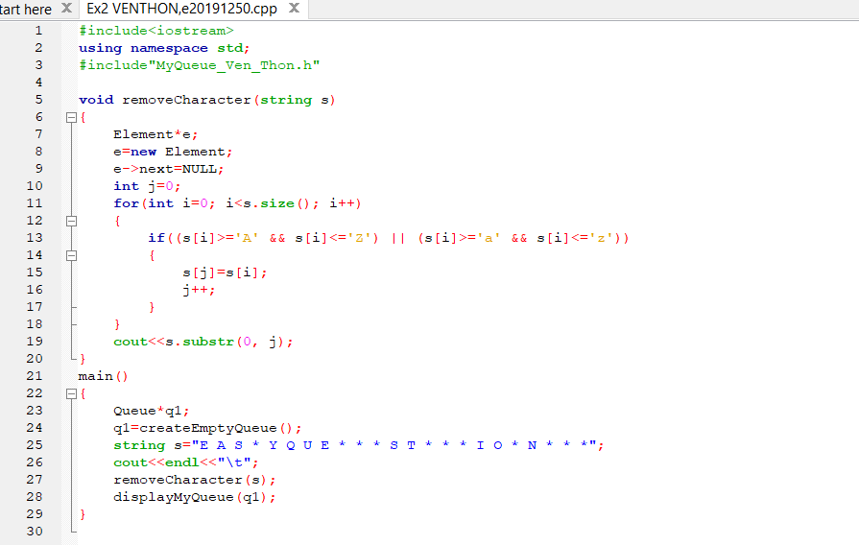

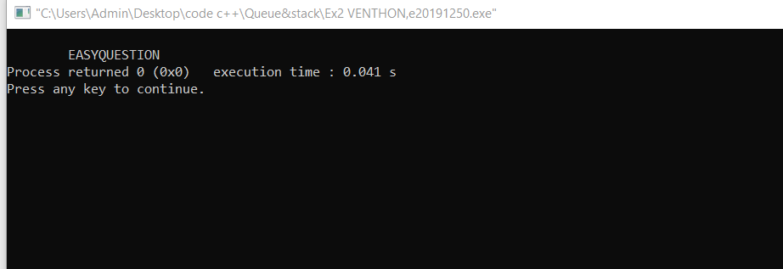

# Problem3:

Write a program to ask a piece of text from a user. Display the text in a reverse order using stack.Hint: Push each character in the text into stack. Display stack.

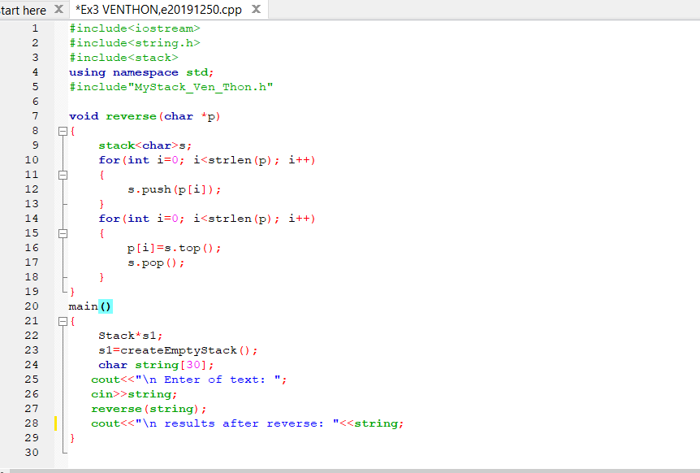

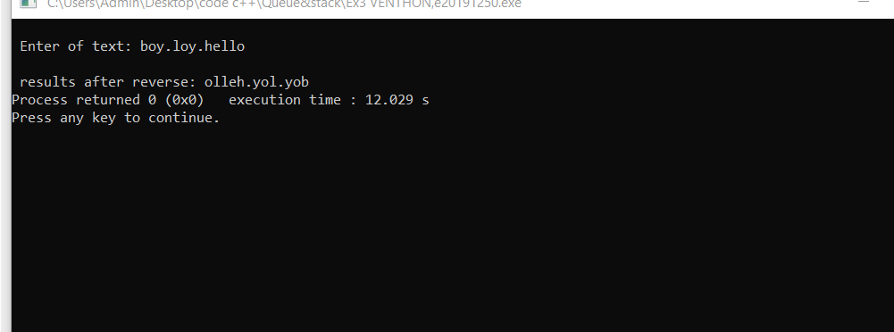

# Problem4:

Write a program to get a number from a user. Use stack to storethat number asthe binary numberrepresentation in the stack. Finally, display the binary representation from the stack. Hint: divide the integer by 2 then store remainder in stack.

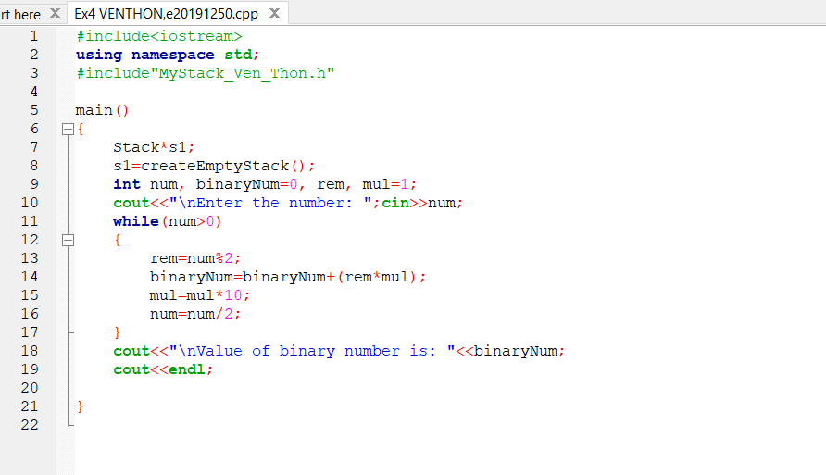

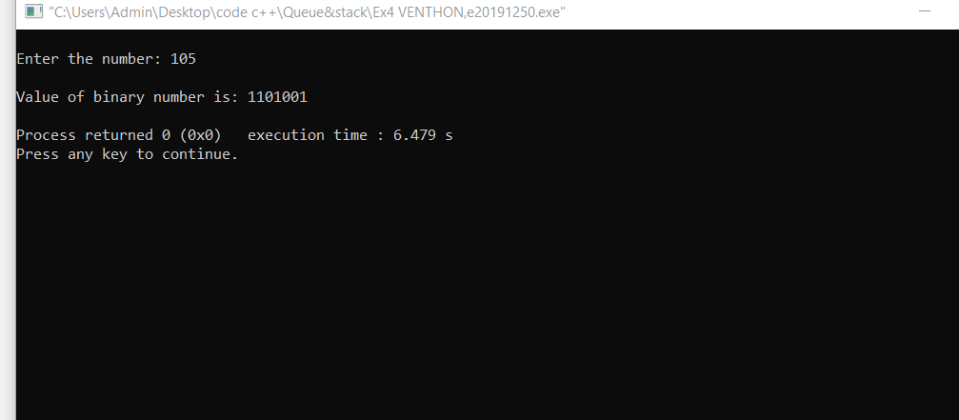

# Problem5:

Store 20random numbers(1 to 1000)in a queue. Create a function voiddequeueKtime(int k) that display and deletek elements from the queue, or until the queueis empty.

